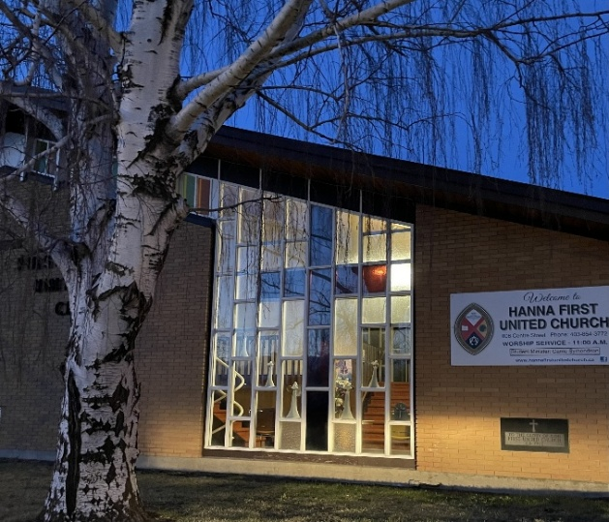
HANNA FIRST UNITED CHURCH
2026 FALL
FUNDRAISING NEWSLETTER

Hello Friends
Well, there is so much to tell you. Since our 2025 newsletter, Hanna First United Church has been through some extraordinary changes. Chairperson Laura Creasy and the members of church council have had to make many challenging and uncomfortable decisions to keep our community of faith together and be able to continue to worship in our beautiful church.

To begin, we want to express gratitude to all those who continue to attend services, read scriptures or Minutes for Mission information, lead us in music, run the power point, count the offerings, set up snacks and refreshments for fellowship and clean up the kitchen afterwards. Also, thank you to those who volunteer their time and expertise in the church or the thrift store when they see a need or whenever they are asked.

Our church has been a cherished gathering place for so many in the community over the years; and our goal is to maintain the church; not just for Sunday services, but for the special services such as the Christmas Eve candlelight service. Many people in the community have fond memories of special occasions held in our church and we want the church to be there for families to be able to celebrate baptisms and weddings or feel the peace and comfort of holding a funeral for a cherished loved one in the years to come.

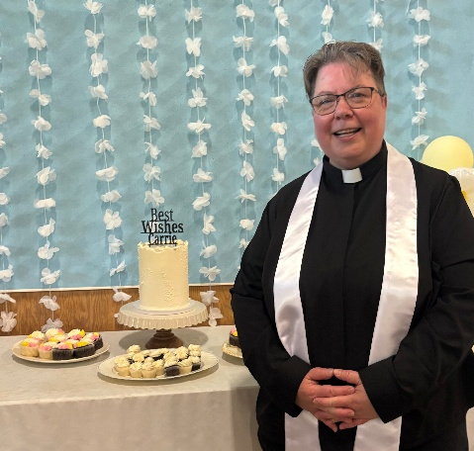
As you will see later in this newsletter, our minister, Rev. Carrie Symondson has accepted a call to another community of faith. Rev. Carrie was very open with the council and congregation as this decision was made. She knew of our financial position and was willing to make this change to help us to remain open with the assistance of Chinook Winds Region and the collaborative ministry program.

Rev. Carrie led worship on Sunday, July 19th for the final time as minister for Hanna First United Church. The service was well attended, and a lovely farewell lunch was held following the service. Rev. Carrie began her ministry with us in October of 2022 and we appreciated her dedication, enthusiasm, and caring spirit. We wish Rev. Carrie and Karl Symondson all the best!

At the Annual Congregational Meeting held March 1, 2026, Chair Laura Creasy accepted the nomination to serve as Council Chairperson for a second term. Tyler Creasy accepted the position of Council Vice Chairperson and Rhonda Lund accepted the position of Council Secretary.
The following people accepted appointments to the various committees of Hanna First United Church for the next term:

- Finance – Linda Quaschnick, Rhonda Lund, Richard Preston & Treasurer Neala-Rea Sprinkhuysen
- Board of Trustees – Tyler Creasy, Cliff Buchanan & Liz Gourlay
- Worship – Jean Lypka, Denise Weins, Gloria Hutton & Sandra Wade
- Pastoral Care – Linda Quaschnick, Gail Smigg, Donna Hickle & Liz Gourlay
- Memorial Park – Winona Gutsche, Lynette Barker, Gwen Snell & Clarke Snell
- Ministry & Personnel – Rhonda Lund & Gwen Snell
- Property – Gwen Snell, Alan Lund & Tyler Creasy
- Thrift Store Executive – Gloria Hutton, Linda Quaschnick, Charlotte Preston
- Funeral Lunch – MaryAnn Campion, Charlotte Preston, Karen Gordon & Rhonda Lund
The position of Chinook Winds Region Representative remains open for someone from the congregation to volunteer.
There were 28 people in attendance at the meeting to discuss the future of Hanna First United Church. This was one of many meetings to discuss how we can remain open and active as a community of faith.
Our Council Chair, Laura Creasy, works tirelessly to present information and financial plans through emails and open meetings to help us all to understand what we are facing. With guidance from Rev. Symondson and Rev. Dr. Karen Medland, Pastoral Relations Minister from Chinook Winds Region, the members of church council have explored all the options we have at our disposal. During council meetings, congregational meetings and zoom meetings, the main question has been “How can we continue to operate for the future?”.
Options that have been explored in depth have included:
- Enter a Memorandum of Understanding to share services of our minister with one or more United Church congregations. This option is no longer viable as by mutual agreement we have broken our covenant with Rev. Symondson.

At the Congregational meeting held June 29, 2026, a motion was passed that at the request of Reverend Carrie Symondson, it is with regret that the covenant for ministerial services between Hanna First United Church and Rev. Carrie Symondson be mutually ended effective July 19, 2026. Rev. Carrie Symondson requested to end our pastoral relationship as she was able to secure a new call with Castor/Coronation, and by ending the covenant in this manner our church was saved significant costs required for ending a covenant.

- Sell the manse and/or park. This could give us a financial boost that would provide funds to operate for a couple more years, but during that time we would have to work hard to revitalize the church.

At the Congregational meeting held June 29, 2026, a motion was passed that for the purpose of providing operating revenue for Hanna First United Church, the Board of Trustees be authorized to request assistance from Chinook Winds Region to make preparations to sell the United Church Manse located at 806 Centre Street. This process has been started but may take months to complete.

There are significant costs to subdivide land and many decisions to make during the process. We are not locked in to selling at this point – we are making preparations, so we are ready if the sale is necessary.

- Centre Street Thrift Store support. As always, we cannot adequately express our appreciation to the thrift store executive, manager and volunteers who work so hard and contribute significantly throughout the year to aid in meeting our financial obligations. The work they do each month to raise funds for the church and community is outstanding.

The Thrift Store also donates to other non-profit organizations in our community. This is in recognition of the fact that not all the volunteers, supporters and donors are directly related to Hanna First United. Consideration must also be given to that fact that the Thrift Store has expenses to operate each month and covers the cost for some church expenses, so they may not have more to give. To ask for more than the thrift store gives now is not fair to that reality.

- Closure. This option is very difficult to consider, but it is a reality that we must face. At a Congregational meeting held April 21st, the option to close the church was on the agenda. Rev. Dr. Medland attended the meeting and brought a proposal forward for a collaborative ministry program where ministers would be hired by Chinook Winds Region to provide services to rural churches on a contract basis. The goal is to ensure there is support for communities of faith to have access to ministers, pastoral care and provision of sacraments.

During the discussion at this meeting Rev. Medland asked those present to say what their favourite thing about the church was. The answers included many different things, but these were mentioned most often:
- Fellowship, Friendship, Camaraderie - Communicating with different people
- The Music, Singing - Familiarity, feeling like a family
- Being greeted as you enter the church - Sense of care for the wider community
- Memories, History, connecting to others - Working at the Thrift Store
- Feeling of peace, coming home - Beauty and serenity of the building

Looking at this list, renewed attendance and other acts of support are crucial to bringing the fellowship, friendship and familiarity back to the church and create new memories. To have a legitimate mandate to provide ministry, requires a congregation. We want to continue the important work of the church as long as we can, so we are inviting you to join us for Sunday Services at Hanna First United Church.

Moving forward, some things will change and some things will stay the same:
- As we do not have a minister at this time, Sunday Morning services will now be held on the 2nd & 4th Sundays each month at 10:30 am, followed by a time for fellowship & refreshments. Additional services will be scheduled if required (Communion Sundays may need to be scheduled depending on minister availability). Any additional services or changes will be advertised on our website (www.hannafirstunitedchurch.ca) or Facebook page (Hanna First United Church).

- A small, but dedicated choir leads the congregation with music from the new United Church of Canada hymn book “Then Let Us Sing” which combines music from Voices United and More Voices.
- Our Christmas Eve candlelight service is always one of our most special services, and we hope to continue this tradition.
- Pastoral care is an important and valuable part of our church, whether it be a visit or a card in the mail. Please contact the church office or members of council if you know of anyone needing pastoral care or if you are interested in providing it on behalf of the church.
- The Thrift store contributes to our annual financial pledge to the United Church of Canada Mission & Service fund, helping people in Canada and throughout the world.

We are proud to be a part of the community of Hanna and the wider community of faith in many ways:
- The Center Street Thrift Store operated by volunteers in the basement of the church is open to customers from 11 a.m. to 4 p.m. on Tuesdays, Wednesdays, Fridays & Saturdays. Through the efforts of the volunteers, funds have been donated to many local non-profit organizations (the Food Bank, JC Charyk School Lunch Programs, Museum, etc.) in addition to the support provided to the Church.
- Memorial Park located east of the church is maintained by volunteers for the enjoyment of anyone who would like to wander through or sit on one of the benches to take in the beauty of the day.
- The church has provided space to host auditions, rehearsals, concerts and recitals that have been enjoyed by many people who attended and donated funds to the church.

Although we will not be able to do as much as we have in the past, what we hope to do for the remainder of 2026 and into 2027 requires a commitment of giving. Council remains unchanged in our financial vigilance in operating and maintaining the church and outreach to members, but it requires financial support.

Each year expenses grow as our buildings age, maintenance and upkeep costs increase, our congregation numbers reduce, and our volunteer base is stretched to the limit. Therefore, our request for your financial gift becomes more crucial. As you review this letter and the attached budget you will see that we have withdrawn all the funds from the investment account to provide operating funds in 2026. The significant contributions raised from this newsletter and the Centre Street Thrift Store will allow us to keep our doors open as much as possible in 2027.
Please speak to any of the members of Council if you have questions, suggestions, or comments regarding the above. Council meets on the 2nd Thursday of each month at 6:00 p.m. in the church lounge and the meetings are open to members of the congregation.
Our heartfelt appreciation to the members of our congregation who provide generous additional contributions, including memorial donations during 2025/2026. Also, to those who provide regular weekly or monthly offerings, we are very grateful for your ongoing support.

We have attached a commitment card / Pre-Authorized Remittance form for our fall fundraising campaign as well as the 2026 budget for your information. We would like to remind everyone of the various ways you can donate to the church (for the fall fundraising campaign or any offerings throughout the year):
- Offering plate at Sunday Services
- Drop in at the church office or Mail to Box 940
- PAR (pre-authorized remittance) Program (see the enclosed brochure)
- Donate Button on our website (www.hannafirstunitedchurch.ca)
- E-transfer through online banking - using email hannafirstunited@gmail.com – no security questions needed as auto-deposit is set up.
If you have questions about any of these options, please contact Neala-Rea Sprinkhuysen at 403-854-8146 or nealarea_veno@live.com.
In whatever way you are able to give, we thank you in advance for your support. God bless.
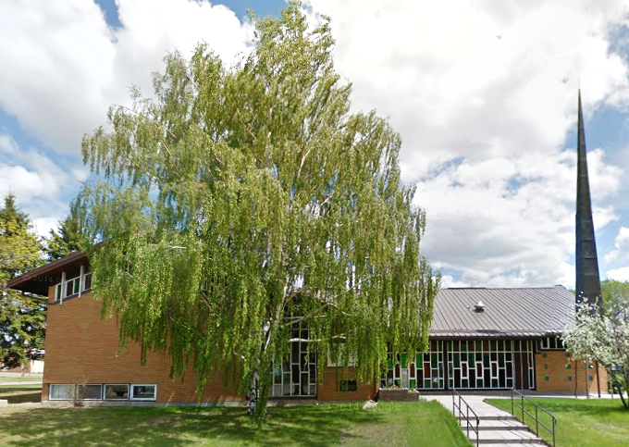
The Finance Committee:
Linda Quaschnick, Rhonda Lund,
Richard Preston and Neala-Rea Sprinkhuysen

Hanna First United Church
808 Centre Street
403-854-3772
hannafirstunited@gmail.com
www.hannafirstunitedchurch.ca

